NAME:VIJAY VARSITH I
ROLL No:241901125

EXPERIMENT 5
PERFORM WEB SERVER RECONNAISSANCE USING VARIOUS TOOLS
AIM:
To identify the type, version, and configuration details of a target web server using reconnaissance tools such as Nmap, Nikto, and WhatWeb.

TOOLS REQUIRED
- Kali Linux – Operating system containing the reconnaissance tools.
- Metasploitable2 – Vulnerable target machine hosting the web server.
- Nmap – To identify open ports, services, and web server versions.
- WhatWeb – To identify web technologies used by the target website.
- Nikto – To identify potential web server vulnerabilities and configuration issues.
- curl – To inspect HTTP response headers.
- Wireshark (optional) – To capture and analyse network traffic.

PROCEDURE
- Start Kali Linux and Metasploitable2 and verify network connectivity using the ping command.
ping -c 4 192.168.56.102
- Perform service and version detection using Nmap to identify open web server ports and running services.
nmap -sV -p 80,443,8080 192.168.56.102
- Use Nmap HTTP scripts to identify the web page title, HTTP headers, and server information.
nmap -p 80 --script=http-headers,http-title,http-server-header 192.168.56.102
- Inspect the HTTP response headers using curl.
curl -I http://192.168.56.102
- Use WhatWeb to identify the web server software, operating system information, PHP version, and other detectable web technologies.
whatweb http://192.168.56.102
- Run Nikto against the target web server to identify potential security issues, outdated software, missing security headers, and directory indexing.
nikto -h http://192.168.56.102
- Record the outputs obtained from the tools, analyse the web server information, and document the potential security issues identified.

OBSERVATION:
TEST PERFORMED | OBSERVATION
Network connectivity using ping | Target 192.168.56.102 was reachable. Four packets were received with 0% packet loss.
Nmap service/version detection | Port 80/tcp was open and running Apache HTTPD 2.2.8 (Ubuntu) DAV/2. Ports 443/tcp and 8080/tcp were closed.
Nmap HTTP scripts | Page title: Metasploitable2 - Linux. Server header: Apache/2.2.8 (Ubuntu) DAV/2. PHP header: PHP/5.2.4-2ubuntu5.10.
HTTP header inspection using curl | Server returned HTTP/1.1 200 OK. Apache and PHP response headers were observed; content type was text/html.
Web technology detection using WhatWeb | Detected Apache 2.2.8, Ubuntu Linux, PHP 5.2.4-2ubuntu5.10, page title Metasploitable2 - Linux, and WebDAV 2.
Web server scan using Nikto | Reported directory indexing, missing recommended security headers, outdated Apache/PHP versions, a phpinfo() page, a browsable /doc/ directory, and HTTP TRACE enabled.
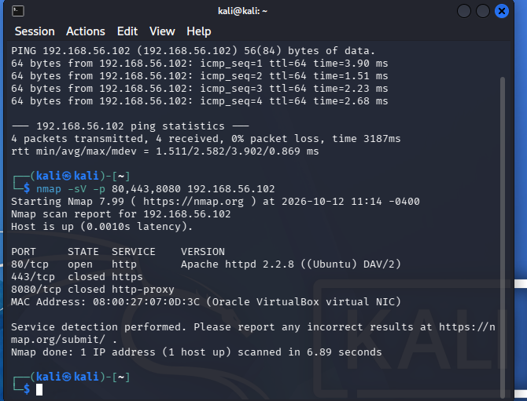
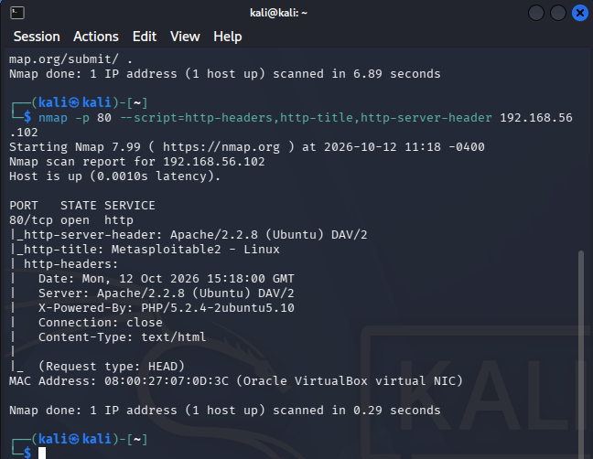
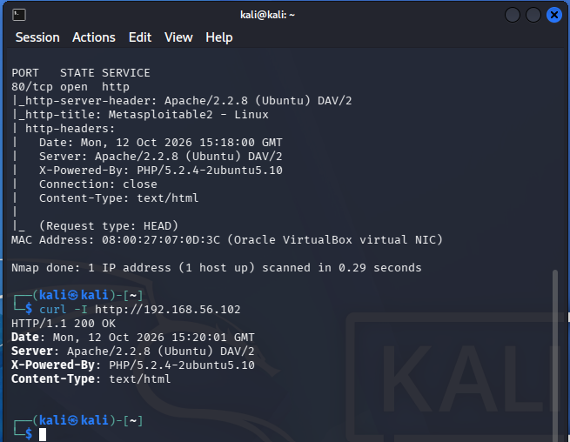
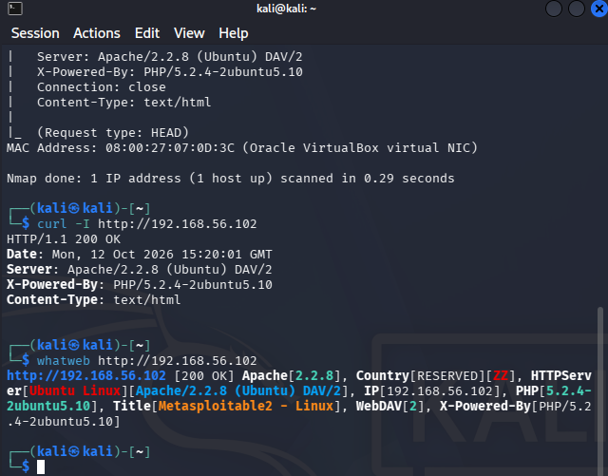
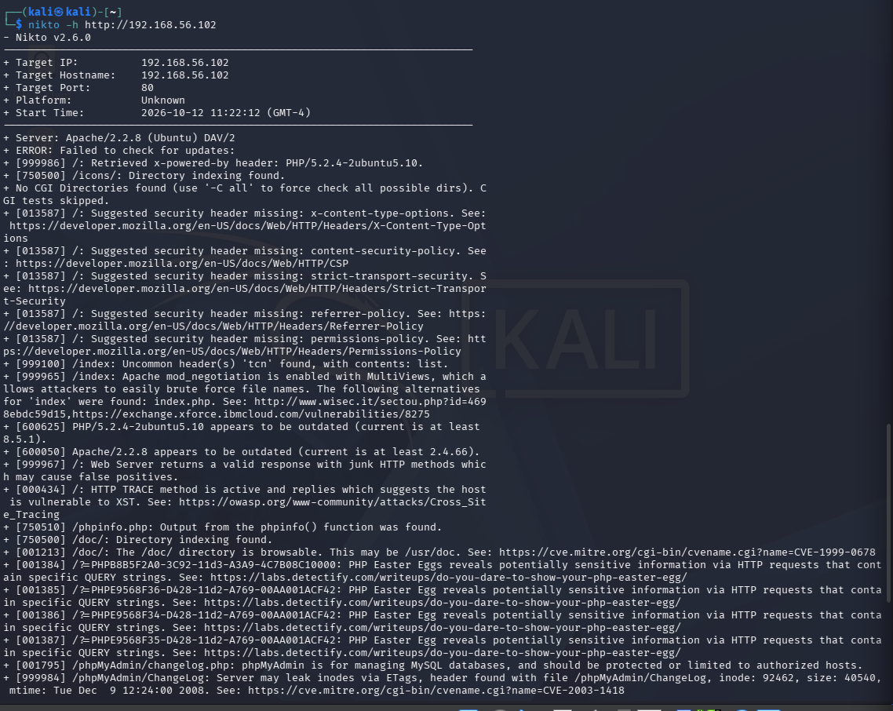
RESULT:
Web server reconnaissance was carried out using Nmap, WhatWeb, Nikto, and curl in an authorised lab environment to examine open ports, service versions, HTTP headers, web technologies, and potential security issues.

